Module 3: IAM Roles Assignment
IAM-Roles-Assignment-–-3

Problem Statement:
You work for XYZ Corporation. To maintain the security of the AWS account and
the resources you have been asked to implement a solution that can help easily
recognize and monitor the different users.
Tasks To Be Performed:
1. Create a role which only lets user1 and user2 from task 1 to have complete
access to VPCs and DynamoDB.
2. Login into user1 and shift to the role to test out the feature.

Task1:
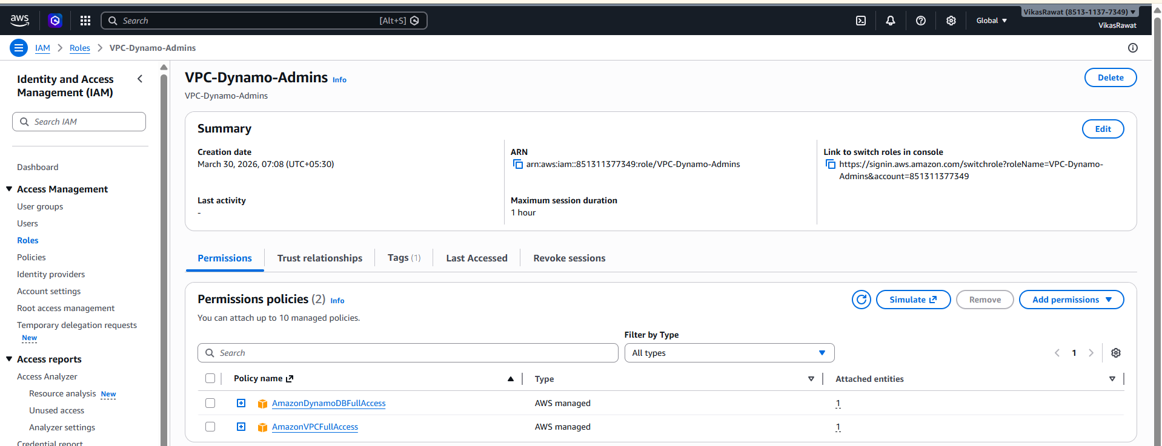
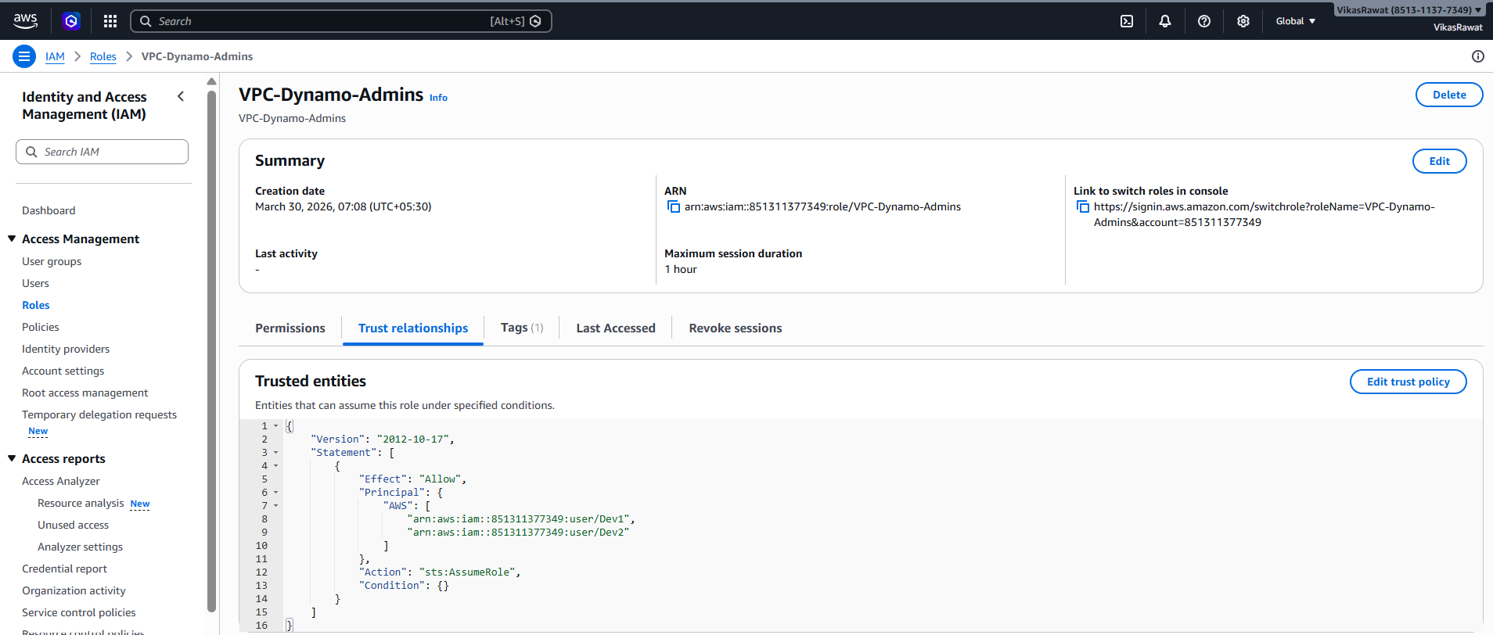

Task2:
